**CPI 211 Game Design Document**

**Group 6:**

Abrar Akhand, Nolan Briner, Leslie Estrella, Kevin Mcallister, Anthony Sonntag, Aiden Robins

**Table Of Contents**

**Game Concept** **2**

Two Sentence Pitch 2

Two Minute Pitch 2

**Gameplay Overview** **3**

Player Mechanics 3

Base Camp and Returning to Camp 3

Player Progression 3

Potions 3

Attack Spells 4

Specific Spells 4

Defense Spells 5

**Enemy Overview** **5**

... 5

**Environment and Level Design** **6**

Environment Design 6

Level Structure 7

**Art Direction Documentation** **7**

Character Design 7

Enemy Design 8

**Approximate Timeline and Milestones** **8**

… 8

**Team Bio** **9**

Kevin McAllister 9

Abrar Akhand 9

Leslie Estrella 9

Nolan Briner 9

Anthony Sonntag 9

Aiden Robins 9

## **Game Concept**

#### **Two Sentence Pitch**

The Sorcerer’s Labyrinth is a 3D roguelike about a wizard ascending a magical tower by blasting his way through everything in his path with a variety of spells. Standing in his way is an army of monsters ready to fire an absolutely astounding number of fireballs and other projectiles that must be dodged if the wizard is to reach his goal, the top of the tower.

#### **Two Minute Pitch**

The game draws inspiration from more forgiving roguelike games (commonly called rogue-lite games) as well as bullet hell games to combine into a difficult game, but one that does not heavily punish failure. The goal of the game is for the main character, a wizard, to climb the tower of the recently deceased Archmage in an attempt to become the new Archmage. However, each floor of the tower is much more dangerous than the last and success on the first try is virtually impossible; instead the wizard must make short forays into the tower to acquire money and resources to improve themselves. Upon leaving the tower, either through death or by clearing a floor and selecting “Exit”, the wizard will return to a base camp (which is a menu) where they can purchase upgrades in the form of permanent buffs and new spells so they can attempt to make it further. The tower itself is not randomized; however, the location of keys and enemies is. To progress to the next floor, the stair key must be found. While exploring the floor, enemies will constantly assault the wizard whenever he enters a certain radius of them. Enemies primarily attack through high-damage projectiles, fitting the game’s bullet hell theme. The wizard is expected to dodge the majority of them to survive through proper positioning and use of various defensive spells. Defensive spells are set before entering the tower and cannot be changed while inside; they are cast using right click and have a cooldown between uses.The wizard can also attack with a variety of spells using left click which can be learned or upgraded through “essence”, a resource enemies drop upon defeat. These spells have a variety of ranges, areas of effect, and damage values- upgrading will generally increase one or more of these values. The player can switch which spell is in use at any time using the scroll wheel or number keys, but only one offensive spell can be used at a time.

## **Gameplay Overview**

#### **Player Mechanics**

The player controls a wizard, who is capable of 3D movement using WASD. The player is also capable of jumping and sprinting using space and left shift, respectively. The player’s main weapon will be a staff that the main character uses to cast magic spells, with offensive spells using left click and defensive spells using right click. They can also use potions with middle click. They have 100 health and die upon it reaching zero. Due to the bullet-hell nature of the game, the game will feature a 3rd person camera so that the player can see projectiles and enemies coming from behind the main character. The

#### **Base Camp and Returning to Camp**

Outside the entrance of the tower is a base camp where the player may upgrade their spells, purchase potions, and enter the tower from the first floor. The player may return to the base camp by completing a floor and deciding to exit instead of continuing on to the next. Death will also return the player to the base of the tower, but at the cost of half of the player’s collected demon essence.

#### **Player Progression**

The player will collect demon essence from enemies slain on each level, with the amount dropped varying based on the type of enemy and the floor they are encountered on; enemies with more heath and on higher floors drop more demon essence. The player may use the demon essence to purchase potions that grant the player a variety of beneficial effects. Demon essence may also be used to upgrade the player’s spells, increasing their damage and/or usability.

#### **Level Progression**

The player’s main objective is to climb to the top of the tower to win the game. The tower has multiple levels which will be all different floor layouts with enemies of different difficulty that will spawn around the map with semi-randomness. Each level will present new enemies that have new mechanics. To progress through the levels of the tower the player must find the “key” to the next level by looking around the level. The key will be used to unlock the way to the staircase that gives the player the option to keep going to the next level or to return to the camp to upgrade their attack spells and regain their health.

#### **Attack Spells**

Attack spells are the player’s main form of dealing damage to enemies, activated by using left click. All attack spells start off at level 0, but can be upgraded at the base camp to a limit of level 10. Upgrade costs increase 50% more for each successive level. At Levels 5 and 10, spells will also gain one of two special effects called “traits” (chosen by the player). There are three attack spells: Fireball, Thunderbolt, and Frost Lance.The player may swap between the active attack spell at any time using the scroll wheel, pressing “Q” or “E” or the number buttons; Fireball is 1, Thunderbolt is 2, and Frost Lance is 3.

##### **Specific Spells**

The **Fireball spell** shoots an exploding flame that deals 25 damage to all enemies hit and can be fired once per second. It has a baseline blast radius of 1 meter. Upgrading Fireball increases the damage by 2 and the blast radius by 5%.

The **Thunderbolt spell** fires an electric beam dealing 15 damage every .5 seconds to the first enemy hit. Upgrading Thunderbolt reduces the time it takes to fire the next Thunderbolt by .025 seconds.

The **Frost Lance spell** summons a blade of ice to cleave in a 90 degree frontal cone with a 1 meter range, dealing 20 damage every .75 seconds and knocking enemies back. Upgrading Frost Lance increases knockback distance and range by 5%, and damage by 1.5 (rounded down when calculating actual damage).

#### **Defense Spells**

Unlike attack spells, defense spells are activated using the right mouse button and cannot be swapped freely. Instead, the player must choose a single defense spell before entering the tower, and they can only use that one spell for the run. Additionally, defense spells have a cooldown between uses (depending on the spell) and cannot be upgraded. There are four defense spells: Blink, Barrier, Gravity Well, and Drain. Blink teleports the player forwards 3 meters, with a 4 second cooldown. Barrier creates a magic shield in front of the player for 3 seconds, blocking all projectiles except the player’s; the barrier is 3 meters wide, cannot be moved once placed, and has a 10 second cooldown. Gravity Well creates an orbat the spot where the player is looking that drags all enemies within 2 meters to it, with a 15 second cooldown. Drain fires an orb that deals 10 damage to the first enemy hit and heals 10% of the player’s maximum health if it hits, with a 30 second cooldown.

## **Enemy Overview**

#### **Enemies**

There will be multiple types of enemies with different methods of attacking the player and movement. The enemies will be firing projectiles all at different speeds, colors, and damage so that the player can have time to see them and dodge them. For the first basic type of enemy it will just be able to shoot at the player once it is in vision and then try to follow the player at a distance to keep it in range. Another type of enemy will be one that will be fast but weak and will try to rush the player and do damage up close. A more uncommon type of enemy would be a bigger enemy that has more health and is slow that will try to get as close as it can to the player. There will be a ranged enemy that will not move at all but when the player is in range it will start to fire at it from a far distance. There will also be an enemy that will throw down projectiles that create an area of effect that will damage the player if they step inside.

* + 1. **Normal Enemy**

The normal enemy will be the most common enemy which can be found on every level of the tower and has average damage, range and movement speed. This enemy will be shooting projectiles at the player whenever it is in range and try to keep the player within range by chasing after them after the first sighting of the player. The projectile that this enemy will be shooting at the player will be a basic fireball spell that will cause 10 damage to the player.

* + 1. **Fast Enemy**

The fast enemy will spawn in hordes since they will have low attack damage and health but will try to rush the player dealing damage as a group. This enemy will have 1 health which can be defeated in one shot by any spell. The enemies attack style will be rushing the player once they have gotten in range and will keep on chasing them. This enemy will do damage by 1 damage melee attacks once they are close enough to the player.

* + 1. **Tank Enemy**

This enemy is a melee enemy that has a lot of hit points. Due to this enemy type having a lot of hitpoints, the enemy also moves slower than the other enemy types.

* + 1. **AOE enemy**

This enemy fires an arched poison blob that creates a temporary pool of poison on the ground that damages the player if they are in it. Appears on later levels.

* + 1. **Long range Enemy**

This enemy fire projectiles and can detect and fire at the player from far away (Has a big attack range). This enemy appears on the later levels and on the final level.

## **Environment and Level Design**

#### **Environment Design**

The environment of our game and its levels will feature a medieval theme. Since the game will mostly take place in a wizard tower that has been abandoned and lost to time.

Images that represent the environment theme that we are going to try to achieve for the game:

Reference Images (not in game) to the style we will try to achieve:

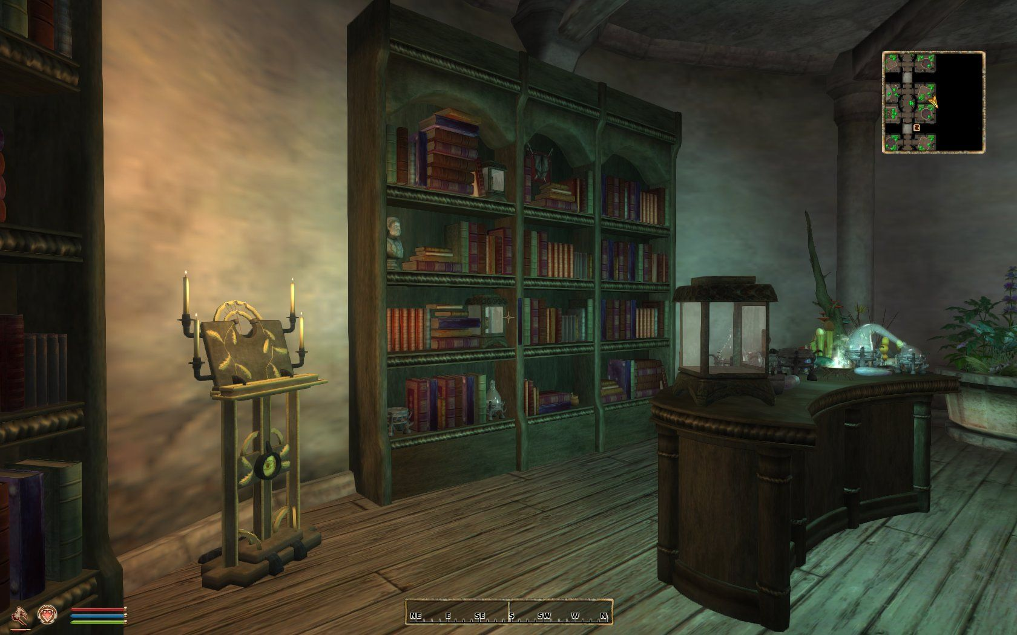

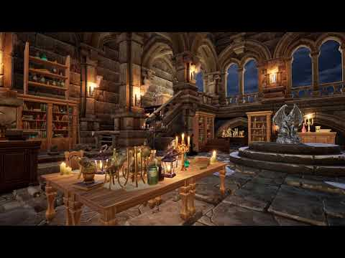

**In game pictures below:**

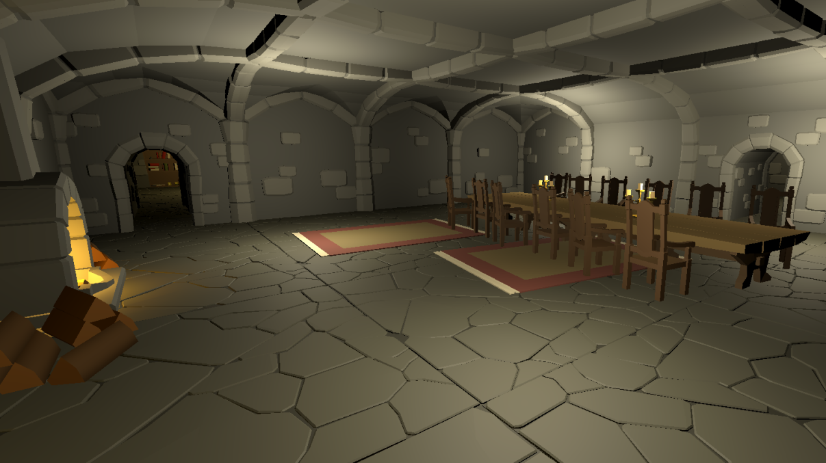

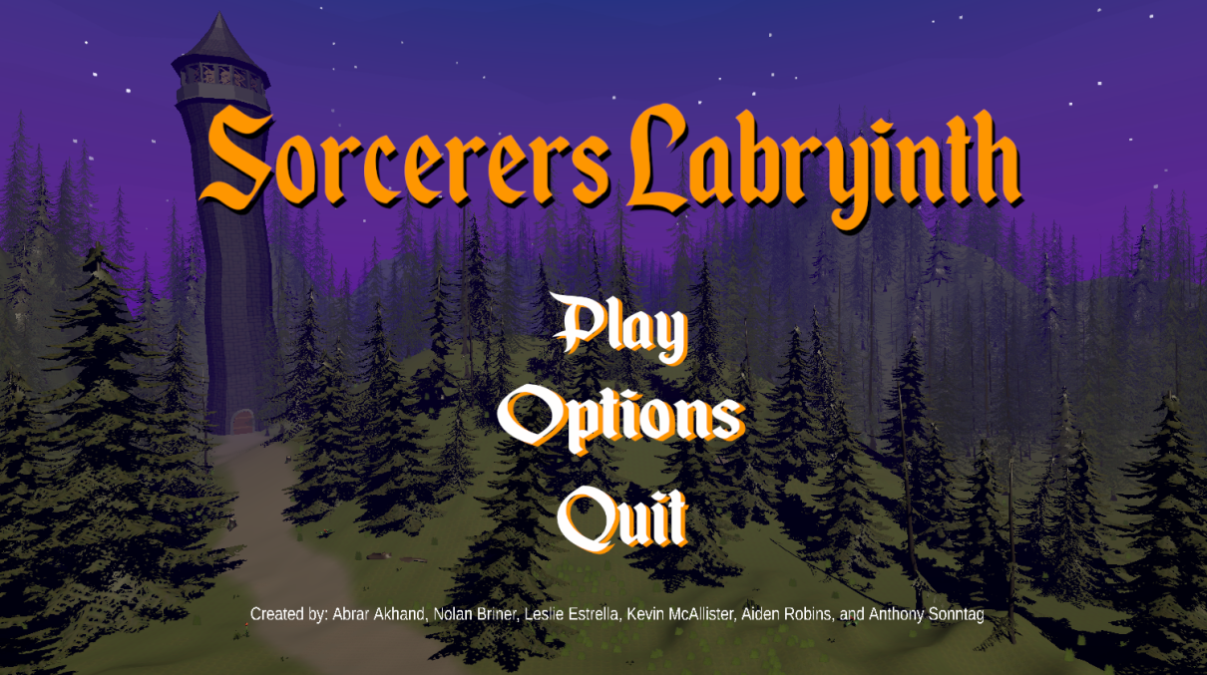

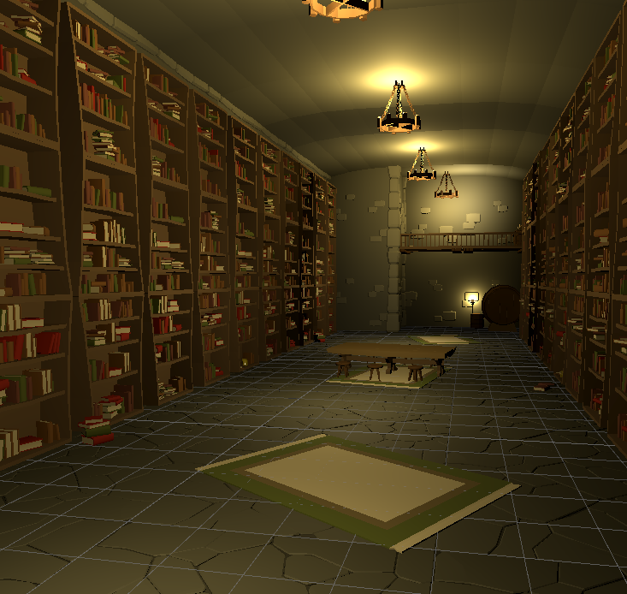

This picture shows what a room in the game might look like. Some objects that will be common in all the levels will have in common are:

* Bookshelves
* Candles
* Wooden Tables
* Books (props on tables)
* Paintings
* Windows
* Stone walls
* Staircases
* Stone Floors (slabs)
* Cauldrons
* Weapon props
* Bones & Skulls

The art style of the assets will be also **low poly** since it will allow use to be more expressive

multiple levels in a tower with each level having a different floor plan that has different rooms and different enemies. The hallways and rooms of the floors will be dimly lit and have a medieval cobblestone design to it.

#### **Level Structure**

The levels will feature rooms where enemies are located. The rooms in each floor/level are fixed but everytime the player visits the same floor, the rooms will feature a theme, for example, in floor/level 2, the room will be a library and will be covered in books. As the player climbs the tower and progresses, the levels will become harder and feature more difficult enemy types.

**Level/Floor 1**

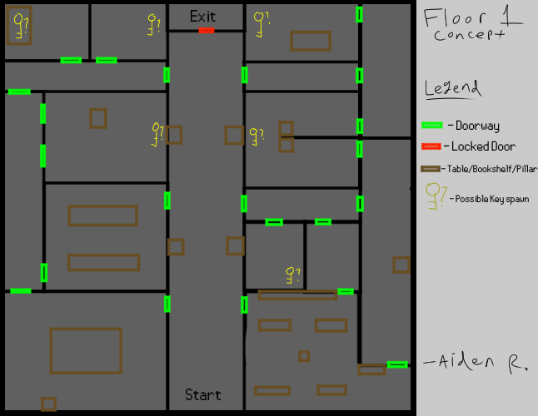

**Level/Floor 2**

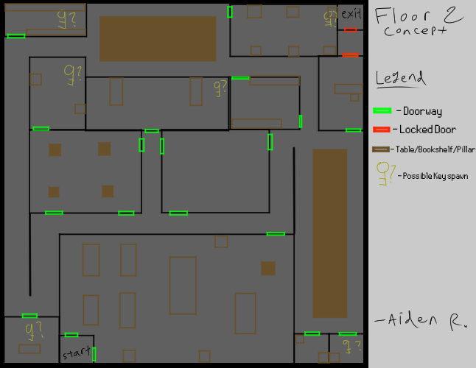

**Level/Floor 3**

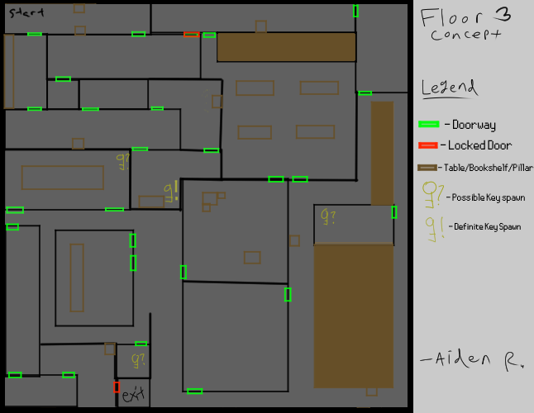

**Final Level/Floor**

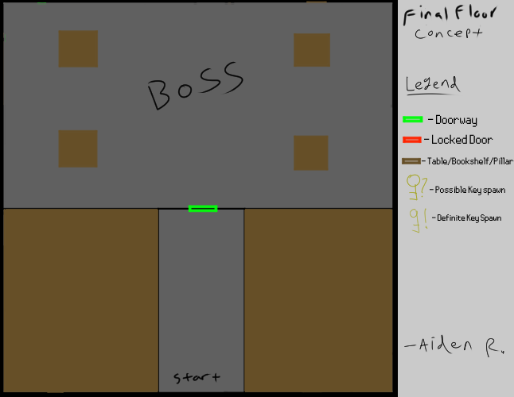

## **Art Direction Documentation**

#### **Character Design**

The main character is a wizard that is trying to become the archmage throughout the game. The wizard (The character the player is playing as, will not be visible in game). The wizard will be holding a magical spell book that will appear to be floating and following the player.

#### **Enemy Design**

Each of the enemies will look like demons each of them having different weapons to reflect how they attack.

Normal Enemy

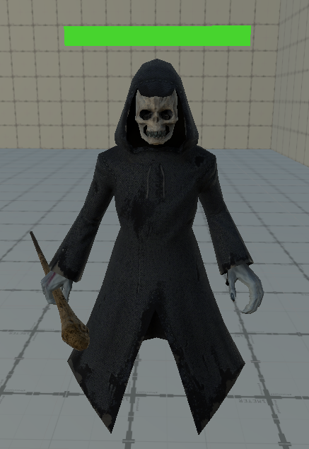

Tank Enemy

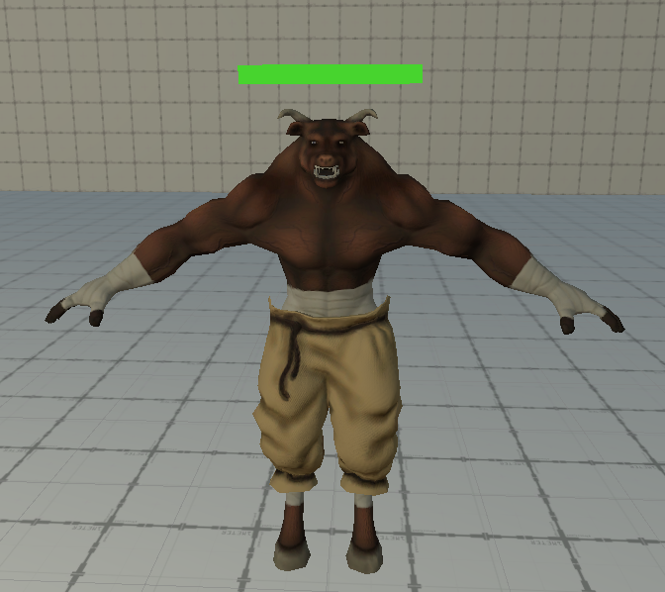

Long Range Enemy

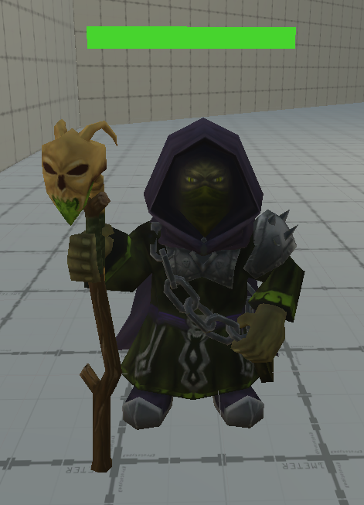

AOE Poison Enemy

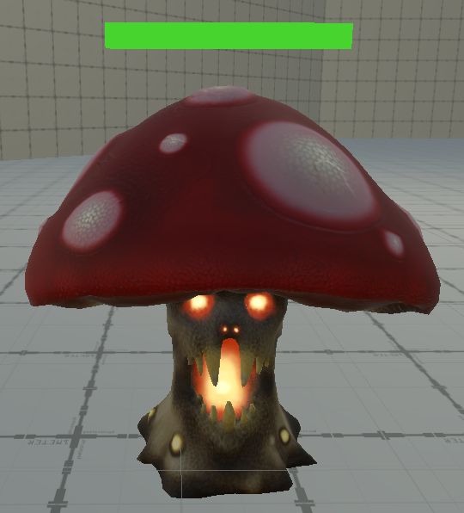

Fast Enemy

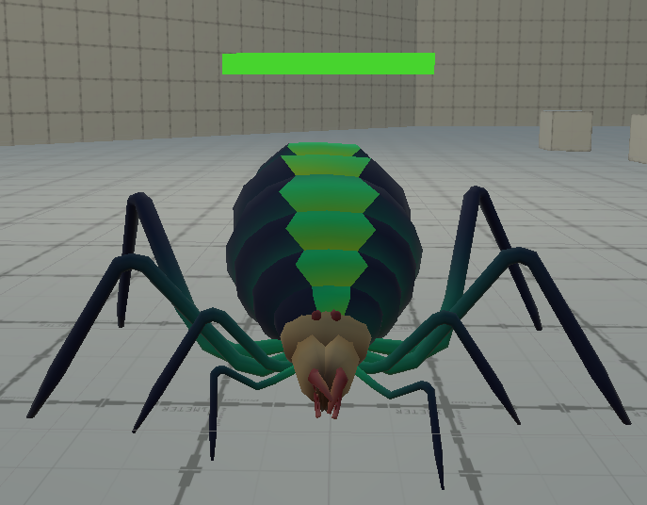

## **Approximate Timeline and Milestones**

#### **November 5th**

* **Abrar Akhand**: Create a basic player controller and first person camera controller, design some defensive spells
* **Leslie Estrella**: Create game menus with controls for volume and game settings.
* **Kevin McAllister**: N/A (didn’t have time)
* **Nolan Briner**: Create a spawner for enemies that will spawn random types of enemies in the level.
* **Anthony Sonntag**:
* **Aiden Robins**: Have some wall and floor textures prepared to showcase during the check-in, and for testing purposes.

#### **November 10th**

* **Abrar Akhand**: Implement the other two defensive/utility spells and setup player input controls
* **Leslie Estrella**:
* **Kevin McAllister**: Program spell projectiles and behaviors (explosion, cleave, beam, etc.)
* **Nolan Briner**: Create the first enemy state machine.
* **Anthony Sonntag**: Models, Life Steal etc.
* **Aiden Robins**: Create level/floor layouts

#### **November 12th**

* **Abrar Akhand**: Create Upgrade screen and its corresponding UI elements. Make the UI show the cost and what the upgrade increases and other information about the spell.
* **Leslie Estrella**:
* **Kevin McAllister**: work on the attack spells
* **Nolan Briner**: Complete the first enemy type/AI
* **Anthony Sonntag**: Find models for the enemies
* **Aiden Robins**: Create textures for UI and stuff

#### **November 17th**

* **Abrar Akhand**: Create visual effects for the defensive spells (gravity well, drain orb, barrier shield and blink) using shaders and particle systems.
* **Leslie Estrella**:
* **Kevin McAllister**: work on the attack spells
* **Nolan Briner**: Create the other enemy types: Tank, Fast, Long Range, AOE and make an enemy spawner
* **Anthony Sonntag**:
* **Aiden Robins**:

#### **November 19th**

* **Abrar Akhand**:
* **Leslie Estrella**:
* **Kevin McAllister**: work on the attack spells + skills + script that calculates the damage/cooldown scaling based on level
* **Nolan Briner**: Animate the enemies using animations and 3D Models.
* **Anthony Sonntag**:
* **Aiden Robins**:

#### **November 24th**

* **Abrar Akhand**: Create main menu/ (make it more aesthetically pleasing) + add better looking spell icons and improve player UI
* **Leslie Estrella**:
* **Kevin McAllister**: work on attack spell talents (not implemented in the end)
* **Nolan Briner**: Create the Level/floor 1 + more work on the enemies
* **Anthony Sonntag**:
* **Aiden Robins**:

#### **November 26th**

* **Abrar Akhand**: Create and finish Level/Floor 2, create a health bar, and fix any bugs that appear, create functioning pause menu, gameover and win scene
* **Leslie Estrella**:
* **Kevin McAllister**: work on attack spell talents (not implemented in the end)
* **Nolan Briner**: Create some vfx for spells
* **Anthony Sonntag**:
* **Aiden Robins**:

#### **December 1st (Due Date???)**

* **Abrar Akhand**: Fixing any bugs left
* **Leslie Estrella**:
* **Kevin McAllister**: work on attack spell talents (not implemented in the end)
* **Nolan Briner**:Create Level 3 and the final level
* **Anthony Sonntag**:
* **Aiden Robins**:

...

## **Team Bio**

#### **Kevin McAllister**

A senior and Computer Science major in charge of coding all the attack spells. Effectively ended up being the head designer because he wrote the pitch off the top of his head and nobody bothered to argue. He also edited the Design Document.

#### **Abrar Akhand**

A student majoring in Computer Science who will program the player controls and abilities in Unity. Has experience using Unity and some using Blender.

#### **Leslie Estrella**

#### **Nolan Briner**

An Electrical engineering student who will work on enemy controllers and the visuals for the enemies. Has experience with programming in unity and 3D modelling in blender.

#### **Anthony Sonntag**

#### **Aiden Robins**